Elfreda-Ann Nerquaye-Tetteh

ELLE PM

PROJECT DOCUMENTS FOR DIGIWEAVE: EMPOWERING YOUTH IN THE KENTE WEAVING INDUSTRY THROUGH DIGITAL SKILLS DEVELOPMENT (BONWIRE)

**TABLE OF CONTENTS**

ABOUT THE SPONSOR 2

PROJECT CHARTER 2

PROJECT STAKEHOLDER REGISTER 6

PROJECT COMMUNICATION PLAN 8

PROJECT SCOPE STATEMENT 10

PROJECT SCHEDULE 13

PROJECT RESOURCE IDENTIFICATION 15

RISK IDENTIFICATION 17

PROJECT PROCUREMENT 19

PROJECT MONITORING AND EVALUATION 19

# ABOUT THE SPONSOR

A company that specializes in developing skills training programs. This company is interested in the development of small and medium enterprises. The company is interested in all SME types but has a particular focus on women, youth and PWDs.

# PROJECT CHARTER

|  |  |
| --- | --- |
| **PROJECT TITLE** | **DIGIWEAVE: EMPOWERING YOUTH IN THE KENTE WEAVING INDUSTRY THROUGH DIGITAL SKILLS DEVELOPMENT (BONWIRE)** |
| **PROJECT SPONSOR** | **EMPRETECH GHANA** |
| **DATE PREPARED** | **31ST JANUARY, 2024** |
| **PROJECT MANAGER** | **ELLEPM** |

|  |  |  |  |  |  |
| --- | --- | --- | --- | --- | --- |
| PROJECT BACKGROUND | | | | | |
| Kente is one of the most widely recognized fabrics in the world. It is a colourful and symbolic woven fabric that has come to be known as the pride of Ghanaian traditional clothing. Its popularity extends to the Black Diaspora as well with significant numbers purchasing the fabric as an identifier of their African identity.  The fabric is typically woven in communities that are dedicated its production and its popularity has led to some of these settlements becoming tourist attractions such as Bonwire, the most popular kente weaving settlement in Ghana. Located in the Ejisu-Juaben Municipal district within the Ashanti Region, Bonwire is a town whose identity is Kente, with virtually the entire community being involved in the production of Kente and the existence of the Bonwire Kente Festival.  The implementation of this training programme will contribute to individual and community development. | | | | | |
| PROJECT JUSTIFICATION | | | | | |
| The production of Kente is an ancient practice and should have developed significantly over the years. However, the kente weaving industry in Bonwire faces a number of challenges that has slowed down its progress. Some of the challenges that have led to the decline of the industry and a lack of development in the area (despite being a tourist attraction) include limited demand and supply, limited knowledge and understanding of the history of kente, rigorous and ancient production technique and lack of export promotion (King et al., 2024).  There is also limited involvement of digital and modern technology in the production process for kente. According to Meena et al. (2023) the weaving/textile industry is likely to interact with digitization and technology within the next decade. It is therefore imperative that the industry is transformed to promote the economic livelihoods of the people while also preserving the rich history of the practice. | | | | | |
| PROJECT PURPOSE | | | | | |
| * The main purpose of this project is to provide essential digital skills to the youth involved in kente production in Bonwire for livelihood promotion as well as the development of their whole community. | | | | | |
| HIGH LEVEL DESCRIPTION | | | | | |
| Digiweave is a program that seeks to enhance the kente industry and promote development in the kente weaving tourist community of Bonwire by providing the youth involved with essential digital skills that can be used to open new opportunities for innovation, data preservation, collaboration and market access. The main idea of this program is to bridge the digital divide between traditional kente weaving by providing targeted training and resources. | | | | | |
| HIGH-LEVEL REQUIREMENTS | | | | | |
| Kente weaving associations should be able to access technological devices.  Kente weaving associations should be able to create an online collection for capturing and preserving historical kente information.  Kente weavers should be able to use digital tools such as Adobe Photoshop and Illustrator and to design kente patterns.  Kente weavers should be able to integrate digital technologies into traditional weaving practices.  Individuals in the industry should be able to develop digital marketing strategies to promote their weaving businesses. | | | | | |
| HIGH-LEVEL RISKS | | | | | |
| 1. Limited internet access 2. Resistance to Digital change 3. Budget overruns 4. Limited participation 5. Shortage of skilled instructors 6. Digital equipment acquisition issues 7. Economic Downturn | | | | | |
| PROJECT OBJECTIVES | | | | | |
| To develop a training programme for weavers, sewers and sellers for digital and entrepreneurial training in the community.  To initially equip 100 kente youth weavers with fundamental digital skills to enhance creativity, productivity, marketing and overall efficiency in kente production. | | | | | |
| PROJECT SCOPE | | | | | |
| The project will include the creation of a structured and interactive digital skills development curriculum, provision of devices for use during program, workshops and practical sessions. | | | | | |
| SUCCESS CRITERIA | | | | | |
| A digital and entrepreneurial training program developed that can be adopted for subsequent sessions.  The project should be completed within budget, within the allocated time and with the selected scope being achieved.  100 kente weavers empowered with digital and entrepreneurial skills. | | | | | |
| PROJECT SCHEDULE MILESTONES | | | | | |
| **Milestones** | | | | **Due Date** | |
| Project Start | | | | 04/03/2024 | |
| Stakeholder Consultation | | | | 15/03/2024 | |
| Initial curriculum framework development | | | | 05/04/2024 | |
| Funding | | | | 08/04/2024 | |
| Awareness Creation | | | | 15/04/2024 | |
| Procurement | | | | 12/06/2024 | |
| Venue Arrangements | | | | 26/06/2024 | |
| Completion of digital and entrepreneurial skills curriculum | | | | 10/07/2024 | |
| Digital Infrastructure Set up | | | | 10/07/2024 | |
| Participant Arrangements | | | | 26/07/2024 | |
| Program end | | | | 08/11/2024 | |
| Project End | | | | 25/11/2024 | |
| PROJECT BUDGET | | | | | |
| The project budget is: **$** 300,000 (Analogous Estimation) | | | | | |
| PROJECT ASSUMPTIONS | | | | | |
| * The kente weaving community is receptive to embracing digital skills for skill development. * There is basic access to the internet in the community. | | | | | |
| PROJECT BENEFITS | | | | | |
| * Positive economic impact. * Youth armed with digital and entrepreneurial skills. * Enhanced efficiency of kente production and commercialization. * Expansion of market for kente. | | | | | |
| PROJECT MANAGER AUTHORITY LEVEL | | | | | |
| Staffing | | They are to align people to achieve a vision | | | |
| Budget | | They cannot change the budget or approve any additional budget without consulting the sponsor of the project. They should use their management skills to manage the budget to be able to complete the project. | | | |
| Communication | | They communicate with the sponsor, team members and other stakeholders. | | | |
| Escalation path for authority limitations | | They are not to accept any changes without first analysing it to make a decision on it. | | | |
| SIGN OFF | | | | | |
|  | NAME | | SIGNATURE | | DATE |
| Executive Sponsor |  | |  | |  |
| Project Manager |  | |  | |  |

# PROJECT STAKEHOLDER REGISTER

|  |  |  |  |  |  |
| --- | --- | --- | --- | --- | --- |
| **STAKEHOLDER** | **PROJECT ROLE** | **CATEGORY** | **REQUIREMENTS** | **COMMUNICATION METHODS** | **STAKEHOLDER ANALYSIS GROUP** |
| Project Sponsor Group | Sign off on major project decisions | Internal | ensure program alignment with groups vision, receive periodic updates, funding for program | meetings, presentations, reports | High Power/High Interest |
| Project Manager | Managing all aspects of the project | Internal | stakeholder collaboration, effective resource allocation, clear scope and objectives | regular team meetings and detailed reports | Medium Power/High Interest |
| Training Vendor | assist in curriculum development, delivering the training content, providing guidance, and facilitating hands-on sessions | External | clearly defined roles, supportive environment | meetings, feedback reports | Medium Power/High Interest |
| Technology Provider | Providing hardware, software and technical assistance for the program | External | appropriate technology provision, regular support and maintenance | Phone calls, meetings | Medium Power/Medium Interest |
| Weavers | Beneficiaries of program | External | accessible training sessions, relevant curriculum | community meetings, announcements, awareness sessions | Low Power/High Interest |
| Local Community Leaders | Support and promote the program | External | participation in decision making, alignment with community needs | community meetings, announcements, awareness sessions | Medium Power/High Interest |
| Educational Institutions | Providing a facility for the program | External | Providing a facility for the program | memorandum of understanding, email, phone calls | Medium Power/Low Interest |
| Government Agency | Supporting skill development program | External | regulatory compliance, resource support | meetings, reports | High Power/Medium Interest |
| Media | Promoting awareness creation | External | accurate reporting | media interviews | Low Power/High Interest |

# PROJECT COMMUNICATION PLAN

|  |  |
| --- | --- |
| PROJECT TITLE: | DIGIWEAVE: EMPOWERING YOUTH IN THE KENTE WEAVING INDUSTRY THROUGH DIGITAL SKILLS DEVELOPMENT (BONWIRE) |
| PROJECT MANAGER: | ELLEPM |
| EXECUTIVE SPONSOR: | EMPRETECH GHANA |
| PRINCIPAL STAKEHOLDER: | EMPRETECH GHANA |
| DATE: | 08/04/2024 |

|  |  |  |  |  |  |  |
| --- | --- | --- | --- | --- | --- | --- |
| DELIVERABLE INFORMATION | RECIPEIENT | PURPOSE | DELIVERY MEDIUM | FREQUENCY | OWNER | DELIVERABLE DOCUMENT |
| Initiation Meeting | All Stakeholders | To gather initial information for the initiation plan | Meeting (Face to face) | First Meeting before the project start date | Project Manager | Agenda  Meeting Minutes |
| Distribute Project Initiation Plan | All Stakeholders | Distribute plan to alert stakeholders of the project scope and to gain their buy in. | Emails  Hard copy delivery | Before Kickoff meeting | Project Manager | Project Initiation plan |
| Kickoff Meeting | Project Sponsor  Project Team  Stakeholders | Introduce the project team and the project. Review project objectives and management approach. Communicate plans and stakeholder roles/responsibilities | Meeting (Face to Face) | Near Project Start Date | Project Manager | Agenda  Meeting Minutes |
| Project Information | Project Sponsor  Stakeholders  Project Team | Deliver important messages across to necessary recipients | Meeting  Emails  Conference calls | As needed | Project Manager | Project updates |
| Project Status Report | All stakeholders | Update stakeholders on the detailed progress of the project | Face to Face/ Virtual Presentation  Written Report  Emails  Template: Status report | Monthly | Project Manager | Project status report |
| Biweekly reports | Management | Update management on the status of the project (achievements and outstanding) | Reports  Meetings | Every Two Weeks | Project Manager | Project weekly report |
| Project Risk | Project Team | Communicate risk faced by the project, unforeseen risk and mitigation resolution if any | Risk Document  Meetings | As Needed | Project Manager | Project Risk  Project Mitigation plan |
| Agenda/Minutes | Project Team | Distribution of minutes taken during meetings together with action points | Emails  SharePoint | After Every Meeting | Project Manager | Minutes |
| Team Meetings | Project team | Group meetings/  Individual meetings for sub-teams, and functional team to review detailed plans (Task, assignments and action items) | Meetings (Face to face/ Virtual) | Weekly | Project Manager | Status Reports |

# PROJECT SCOPE STATEMENT

|  |  |
| --- | --- |
| **PROJECT NO.** | **DATE SUBMITTED** |
| DIGIWEAVE: EMPOWERING YOUTH IN THE KENTE WEAVING INDUSTRY THROUGH DIGITAL SKILLS DEVELOPMENT (BONWIRE) | 08/04/2024 |
|  | |
| **PROJECT GOAL AND OBJECTIVES** | |
| Goal: The main purpose of this project is to provide essential digital skills to the youth involved in kente production in Bonwire  Objectives:  To develop a training programme for weavers, sewers and sellers for digital and entrepreneurial training in the community.  To initially equip 100 kente youth weavers with fundamental digital skills to enhance creativity, productivity, marketing and overall efficiency in kente production. | |

|  |  |
| --- | --- |
| **PROJECT DELIVERABLES** | |
| **DELIVERABLE NO.** | **DESCRIPTION** |
| 1 | Community Awareness |
| 2 | Digital infrastructure set up |
| 3 | Digital and Entrepreneurial Skills Training Curriculum |
| 4 | Training |

|  |  |  |  |  |
| --- | --- | --- | --- | --- |
| **Work breakdown structure (WBS) attached** | **NO** |  | **YES** | **✔** |

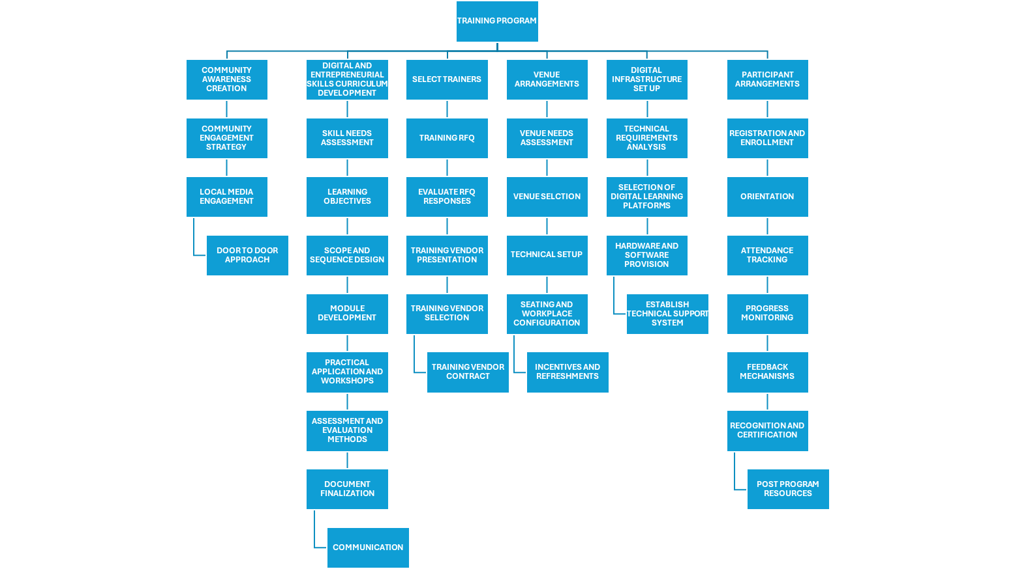

|  |  |
| --- | --- |
| **OUT OF SCOPE** | The project **excludes** physical infrastructure development (building construction) or extensive hardware deployment beyond what is necessary for the training program. |

|  |  |
| --- | --- |
| **PROJECT ASSUMPTIONS** | |
| **NO.** | **ASSUMPTION** |
| 1 | The kente weaving community is receptive to embracing digital skills for skill development. |
| 2 | There is basic access to the internet in the community. |

|  |  |
| --- | --- |
| **PROJECT CONSTRAINTS** | |
| **PROJECT START DATE** | 04/03/2024 |
| **PROJECT END DATE** | 05/11/2024 |
| **DATES / MILESTONES** | Project Start 04/03/2024  Stakeholder Consultation 15/03/2024  Initial curriculum framework development 05/04/2024  Funding 08/04/2024  Awareness Creation 15/04/2024  Procurement 12/06/2024  Venue Arrangements 26/06/2024  Completion of digital and entrepreneurial skills curriculum 10/07/2024  Digital Infrastructure Set up 10/07/2024  Participant Arrangements 26/07/2024  Program end 08/11/2024  Project End 25/11/2024 |
| **BUDGET CONSTRAINTS** | The total budget for the project is **$ 300,000.00.** |

# PROJECT SCHEDULE

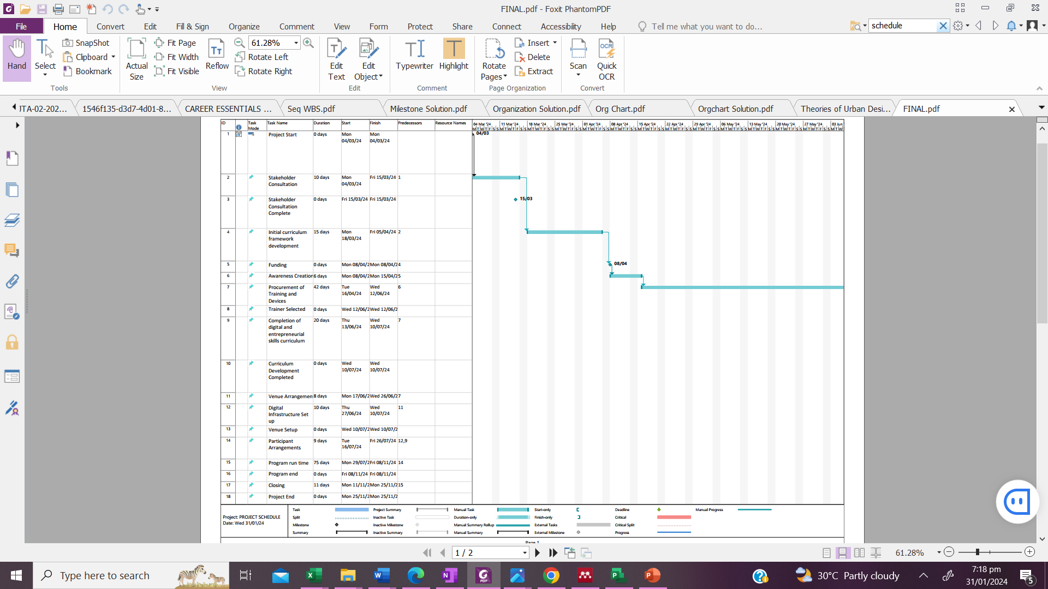

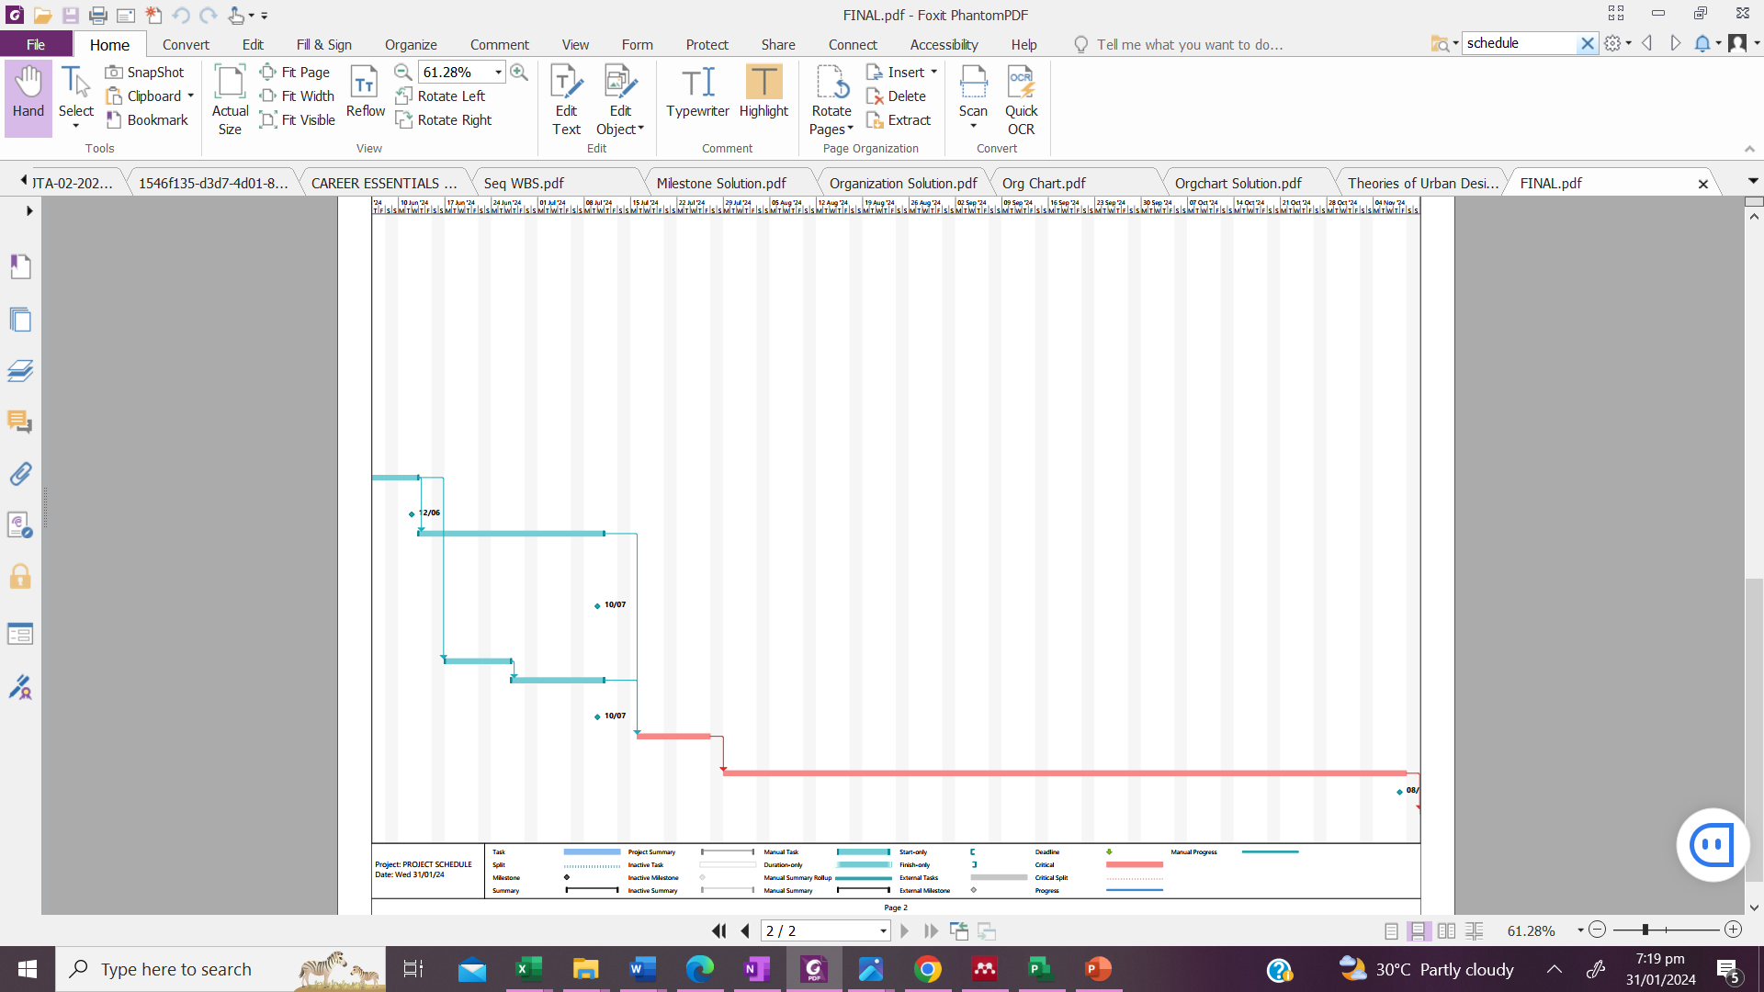

# PROJECT RESOURCE IDENTIFICATION

|  |  |  |  |  |
| --- | --- | --- | --- | --- |
| Requirements | Skills Needed | Role | Qualifications | Experience |
| Contract documentation | * Financial Analysis * Understanding of Contract law * Strong understanding of agreements * Negotiation skills and planning | Finance Manager | Certified Public Accountant or Chartered Accountant | Minimum 8 years |
| Procurement Manager | Degree or higher | Minimum 5 years |
| Procurement Plan | * Negotiation skills and planning * Cost Management skills * Contract Management Skills * Strategic Sourcing Skills * Financial Knowledge | Procurement Manager | Degree or higher | Minimum 5 years |
| Financial Plan | * Financial Analysis * Accounting savvy * Understanding of statistical modelling software and spreadsheets * Mathematical proficiency | Finance Manager | Certified Public Accountant or Chartered Accountant | Minimum 8 years |
| Stakeholders Register | * Stakeholder analysis * Requirements engineering * Oral and written communication skills * Interpersonal and consultative skills | Project Manager | PMP Certified | Minimum 5 years |
| Activity Scheduling Plan | * Project Planning * Project Scheduling * Task Management * Proficiency with Project Management Software * Team Management | Project Manager | PMP Certified | Minimum 5 years |
| Risk Management Plan | * Risk Management * Problem solving skills | Project Manager | PMP Certified | Minimum 5 years |
| Resource Management Plan | * Team Management * Proficiency with Resource Management tools * Task prioritization | Project Manager | PMP Certified | Minimum 5 years |
| Training Segment | * Curriculum Development * Lesson Planning * Content Delivery * Practical Sessions and Workshop organisation * Assessment and Evaluation | Training Enterprise Representative | Degree, Certification | Minimum 10 years experience offering training services |
| Technology Provision | * Hardware provision * Software installation * Technical Support | Technology Provider Representative | Degree, Certification | Minimum 5 years experience offering technology provision services |
| Curriculum Development | * Needs Assessment * Research and Content Development * Curriculum Design * Assessment and Evaluation | Curriculum Developer | Degree or higher | Minimum 10 years experience |

# RISK IDENTIFICATION

|  |  |  |  |  |  |  |  |  |  |  |  |
| --- | --- | --- | --- | --- | --- | --- | --- | --- | --- | --- | --- |
| **Project** | **Training project** |  |  |  |  |  |  |  |  |  |  |
| last updated | |  |  |  |  |  |  |  |  |  |  |
|  |  |  | Rank from 1 lowest to 5 highest | Rank from 1 lowest to 5 highest |  |  |  |  |  |  |  |
| **Risk ID** | **Description** | **Trigger** | **Probability** | **Impact** | **Score** | **Owner** | **Response** | **Response Strategy** | **Expected Results** | **Status** | **Notes** |
| 1 | Limited internet access |  | 3 | 3 | 9 | Project Manager | Mitigate risk | Assess internet access through a survey, Provide offline resources where possible |  |  |  |
| 2 | Resistance to Digital change |  | 2 | 5 | 10 | Project Sponsor | Mitigate risk | Implement a comprehensive change management strategy, including awareness campaigns and workshops |  |  |  |
| 3 | Budget overruns |  | 2 | 4 | 8 | Finance Manager | Mitigate risk | Detailed Budget Development with contingency funds and management reserves, Regular monitoring |  |  |  |
| 4 | Limited participation |  | 2 | 5 | 10 | Project Manager | Mitigate risk | Offer incentives to promote engagement, engage in targeted/door to door outreach |  |  |  |
| 5 | Shortage of skilled instructors |  | 2 | 5 | 10 | Procurement Manager | Avoid risk | Secure funding early, explore technological partnerships |  |  |  |
| 6 | Digital equipment acquisition issues |  | 1 | 4 | 4 | Procurement Manager | Accept | _ |  |  | Note: There is no response strategy as this risk's score is less than 9. |
| 7 | Economic Downturn |  | 2 | 5 | 10 | Project Sponsor | Mitigate risk | Diversify funding sources, establish partnerships, and offer flexible participation options for economically impacted individuals. |  |  |  |

# PROJECT PROCUREMENT

|  |  |  |  |  |  |  |
| --- | --- | --- | --- | --- | --- | --- |
| PROCUREMENT ENTITY: ELLEPM | | | | | | |
| Contract Package | Plan vs Actual | Package Number | Procurement Method | Contract Type | Tendering Period and Evaluation | Contract Finalization |
| Training | Plan | ELL/CH/SER/001/24 | RFQ | FFP |  | 10/05/2024 |
| Actual |  |  |  |  |  |
| Digital Infrastructure Set up | Plan | ELL/CH/GDS/001/24 | NCT | FFP |  | 08/07/2024 |
| Actual |  |  |  |  |  |

# PROJECT MONITORING AND EVALUATION

An empowered new generation of skilled and digitally literate weavers, fostering innovation, entrepreneurship, and community building within the traditional weaving industry.

**IMPACT**

**OUTCOMES**

Increased proficiency in digital skills among participants.

Growth in online presence and market reach for participating weavers.

Curriculum Developed

Technology Provided

Participants Trained

**OUTPUT**

Curriculum Development

Awareness Creation

Venue Arrangements

Training

Technology Provision

**ACTIVITIES**

Human Resource

Hardware

Software (Digital tools)

Financial resources

Educational Facility

**INPUTS**

RESULTS CHAIN FOR TRAINING PROGRAM

|  |  |  |  |  |  |  |  |  |
| --- | --- | --- | --- | --- | --- | --- | --- | --- |
| **ELLEPM** | | | | | | | | |
| **ACTIVITY** | **OUTCOME** | **PURPOSE** | **INDICATOR** | **UNIT OF MEASURE** | **DATA COLLECTION SOURCE** | **DATA COLLECTION METHOD** | **FREQUENCY** | **RESPONSIBLE PERSON** |
| **Awareness Creation** | Digital Change Accepted | Awareness creation is carried out to ensure that potential participants understand what the program is about, the benefits they would gain and encourage them to participate. | Percentage of people reached | Percentage | Primary | Using the M&E questionnaire and checklist | Weekly | Project Manager |
| **Curriculum Development** | Digital and Entrepreneurial Skills Curriculum Developed | To provide a structured and comprehensive framework for the training | Percentage of curriculum completed | Percentage | Primary | Using checklist | Weekly | Curriculum Developer |
|  |  |  |  |  |  |
| **Training** | Participants Trained, Assessed and Certified | To promote digital and entrepreneurial skill development | Number of participants that completed the program | Number | Primary | Attendance  Assessment | Every Session | Trainers |
| **Venue Arrangements** | Facility for training to take place obtained | To provide a conducive environment for training to take place | Facility obtained | - | Primary | MOA | Daily | Project Manager |
| **Technology Provision** | Hardware and Software needed for the program provided | To provide a conducive environment for training to take place | Number of devices obtained | Number | Primary | Using checklist | Weekly | Project Manager |
| Software installed on all devices | Number | Primary | Using checklist | Daily | Project Manager |